Governor Profile

Student’s Name:
Institution:
Course:
Professor:
Date:

Governor Profile – Texas
- Pick any Texas Governor other than Greg Abbott. (http://en.wikipedia.org/wiki/List_of_Governors_of_Texas)
Rick Perry
- Include a picture of the governor.
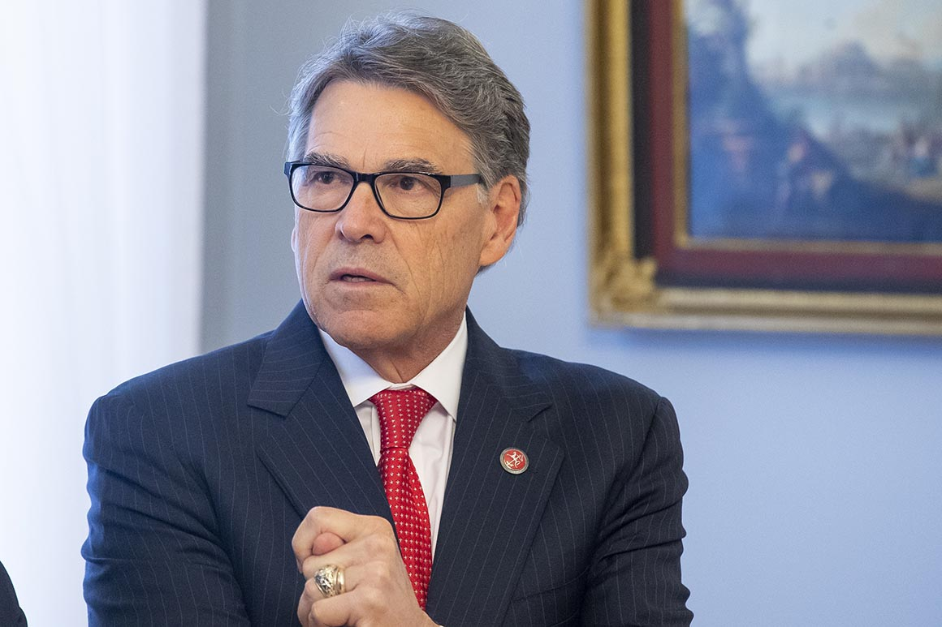
- Name the political party this governor represented.
Republican Party
- List any governmental positions held before becoming governor
  - Name the dates the positions were held
Lockheed C-130 Hercules pilot - Dyess Air Force Base
Door-to-door book salesman - Southwestern Advantage (the 1970s)
- Personal information
  - Date of Birth, Death (if deceased)
March 4, 1950
  - Birthplace
Haskell, Texas
  - Education
    - Include only degrees and schools attended after high school
Pilot training with the United States Air Force - 1974
Texas A&M University – BSc. Animal Science (1972)
- Gubernatorial Elections or assuming of office
  - Indicate how he came into office (won election, assumed governorship upon death or resignation of…)
Rick Perry is the longest Texas governor after serving for three terms. He assumed office in 2000 after George W. Bush resigned to concentrate on his presidential campaign. Rick Perry retained his seat during the 2002 gubernatorial elections against Tony Sanchez. He garnered 58% of the votes, while Tony earned 40%. Furthermore, Perry contested and won 2006 by 39% of votes against Chris Bell (30%), Carole Keeton Strayhorn (18%), and Kinky Friedman (12%). He set a record in 2010 after his reelection to the Texas gubernatorial seat for the third time. He defeated his closest competitor Bill White by garnering 55% against 42%. Rick Perry did not contest the 2015 elections after completing his term. He served for 13 years as the Governor of Texas State. His election and reelection complied with Article 4 Section 2 of The Texas Constitution.
- Vetoes
  - Write a one-paragraph summary of a particular bill that your governor vetoed.
The governor is renowned for vetoing the "Dark Money" Bill passed as Senate Bill 346. This regulation is aimed at tax-exempt, politically active non-profits. Perry supported the need for these institutions to justify their donors and source of funding (Ramshaw, 2013). He intended to protect the Texans from threats and harassment that force them to contribute to political non-profit organizations. Article 4 Section 14 of the Texas Constitution elaborates on the gubernatorial veto. It gives the governor the power and responsibility to approve every bill passed by the legislative houses.
- Write a two-paragraph (single-spaced) summary of any speech given by this governor. In your summary be sure to note any policy positions or social views the governor takes.
https://youtu.be/IO38OOI69Yg
This video reveals Rick Perry's position on abortion and the right to life. This was an anti-abortion speech in Los Angeles on 11th June 2011. Perry's speech targeted the Latino audience and encouraged them to preserve their values and cultures that protect the lives of the unborn. He promises to defend the lives of the Spanish-speaking group for opposing the abortion laws. Perry states that life is a sacred gift from God. As a result, it must be protected at all costs. Perry considered that the solution to this dilemma is to provide laws governing alternative options to abortion.
- Find one op-ed published in a newspaper about the tenure of this governor.
https://www.washingtonpost.com/blogs/govbeat/wp/2015/01/20/the-rick-perry-era-comes-to-an-end-in-texas/
Rick Perry was Texas governor for 14 years before his term tenure ended in 2015. Wilson (2015) evaluates the changes and improvements he made during this period. He argues that Perry has a lasting legacy in Texas regardless of the legislative battles that might follow (Wilson, 2015). The governor prioritized the needs and desires of Texas residents. For instance, he championed Texas's exceptionalism in employment opportunities, conservative governance, and quality of life. Perry intended to eradicate the old stereotypes against the weak and vulnerable in society.
Wilson (2015) considers Rick Perry's position the best in the world. He compares it to being the chief executive of a particular state. The author recognizes that through Perry’s guidance, Texas's economy, innovation, and quality of life grew spontaneously (Wilson, 2015). This was due to the federalism and limited government approaches adopted by Perry’s administration. Even so, the article argues about the likelihood of new governors overturning controversial policies and bills passed by Rick Perry. For instance, he supported the pay of in-state tuition at public high schools by undocumented students. Similarly, the author confirms the cancellation of Perry's $145 billion infrastructure project. This scheme faced criticism from his rivals during his reelection campaign in 2006.
On the other hand, Wilson (2015) argues that Texas gubernatorial seat is less influential than in many states. This contributed to Perry's longevity in that position. However, his administration played a critical role in uplifting performance levels. The writer claims that Rick Perry deserves credit for his tremendous efforts. He transformed the state's business model to attract investors (Wilson, 2015). Besides, he initiated effective policies to enhance the quality of life for Texas residents. Furthermore, they embraced diversity and minimized discrimination regardless of an individual's social status.

References
Ramshaw, E. (2013, May 25). Perry Vetoes “Dark Money” Bill. The Texas Tribune. https://www.texastribune.org/2013/05/25/perry-vetoes-dark-money-bill/
Wilson, R. (2015). The Rick Perry era comes to an end in Texas. Washington Post. https://www.washingtonpost.com/blogs/govbeat/wp/2015/01/20/the-rick-perry-era-comes-to-an-end-in-texas/

